**Mac Installation**

1. Download [VirtualBox](https://www.virtualbox.org/wiki/Downloads) > VirtualBox 5.0.20 for OS X hosts [amd64](http://download.virtualbox.org/virtualbox/5.0.20/VirtualBox-5.0.20-106931-OSX.dmg)
   1. VirtualBox-5.0.20-106931-OSX.dmg
2. Install VirtualBox on Mac
   1. Double click on VirtualBox-5.0.20-106931-OSX.dmg
   2. Double click on VirtualBox.pkg
   3. Open from Applications Folder
3. Copy csnsql.zip to ~/VirtualBoxVMs/
4. Unzip
5. Launch Finder > Browse to ~/VirtualBoxVMs/ > sqlscn
   1. Confirm you can see **sqlscn.vbox** in finder
6. Launch VirtualBox
   1. See: Welcome to VirtualBox
7. Double click file: **sqlscn.vbox** in Finder
   1. Confirm you can see sqlscn in left window of VirtualBox
8. File > Import Appliance
9. VirtualBox > Preferences > Network > Nat Networks
10. Launch VirtualBox on Mac

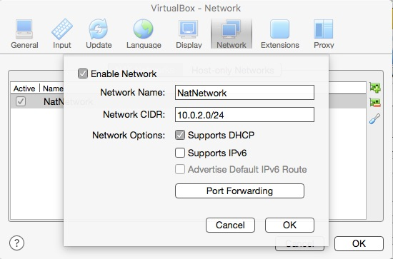

1. VirtualBox > Preferences > Network > Host-only Networks > vboxnet0

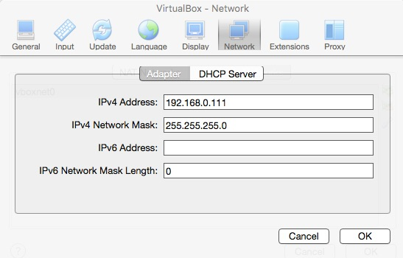

1. Machines > Network > Adapter 1 > Nat >
   1. Adapter Type > Intell PRO/1000 MT Desktop (82540EM)
   2. Cable Connected (checked)
2. Start Windows 8.1 VM
   1. Password: CSNPassword
3. Devices > Insert Guest Additions CD Image (wait 15-30 seconds)
4. Tap to Choose what to do with this disc
   1. Run VBoxWindowsAdditions.exe
5. Restart Windows 8.1 VM